UNITED STATES
SECURITIES AND EXCHANGE COMMISSION
Washington, D.C. 20549

FORM 8-K

CURRENT REPORT
Pursuant to Section 13 OR 15(d) of The Securities Exchange Act of 1934

Date of Report (Date of earliest event reported): August 4, 2023

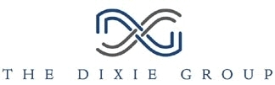

THE DIXIE GROUP, INC.
(Exact name of registrant as specified in its charter)

Tennessee |  |  |  |  |  | 0-2585 |  |  |  |  |  | 62-0183370
(State or other jurisdiction of incorporation) |  |  |  |  |  | (Commission File Number) |  |  |  |  |  | (I.R.S. Employer Identification No.)

475 Reed Road |  |  | Dalton |  |  | Georgia |  |  | 30720
(Address of principal executive offices) |  |  |  |  |  |  |  |  | (Zip Code)

(706) |  |  | 876-5800
(Registrant's telephone number, including area code)

(Former name or former address, if changed since last report.)

Check the appropriate box below if the Form 8-K filing is intended to simultaneously satisfy the filing obligation of the registrant under any of the following provisions (see General Instruction A.2. below):

o Written communications pursuant to Rule 425 under the Securities Act (17 CFR 230.425)
o Soliciting material pursuant to Rule 14a-12 under the Exchange Act (17 CFR 240.14a-12)
o Pre-commencement communications pursuant to Rule 14d-2(b) under the Exchange Act (17 CFR 240.14d-2(b))
o Pre-commencement communications pursuant to Rule 13e-4(c) under the Exchange Act (17 CFR 240.13e-4(c))

Securities registered pursuant to Section 12(b) of the Act:
Title of each class |  |  |  |  |  | Trading Symbol(s) |  |  |  |  |  | Name of each exchange on which registered
Common Stock, $3 Par Value |  |  |  |  |  | DXYN |  |  |  |  |  | NASDAQ Stock Market, LLC

Indicate by check mark whether the registrant is an emerging growth company as defined in Rule 405 of the Securities Act of 1933 (§230.405 of this chapter) or Rule 12b-2 of the Securities Exchange Act of 1934 (§240.12b-2 of this chapter).
Emerging growth company o

If an emerging growth company, indicate by check mark if the registrant has elected not to use the extended transition period for complying with any new or revised financial accounting standards provided pursuant to Section 13(a) of the Exchange Act. o

1

Item 7.01 Regulation FD Disclosure.
The information attached as Exhibit 99.1 hereto supersedes the investor presentation previously furnished on Form 8-K dated May 04, 2023 and is being furnished pursuant to Item 7.01; such information, including the information excerpted below in this Item 7.01, shall not be deemed to be "filed" for any purpose.

These updated investor presentation materials may be found on the Company's website at https://investor.dixiegroup.com.

Item 9.01 Financial Statements and Exhibits.
(c) Exhibits
(99.1) Presentation Materials, August 04, 2023.

2

SIGNATURES
Pursuant to the requirements of the Securities Exchange Act of 1934, the registrant has duly caused this report to be signed on its behalf by the undersigned hereunto duly authorized.

Date: August 04, 2023 |  |  |  |  |  | THE DIXIE GROUP, INC.
 |  |  |  |  |  | By: /s/ Allen L. Danzey
 |  |  |  |  |  | Allen L. Danzey
 |  |  |  |  |  | Chief Financial Officer

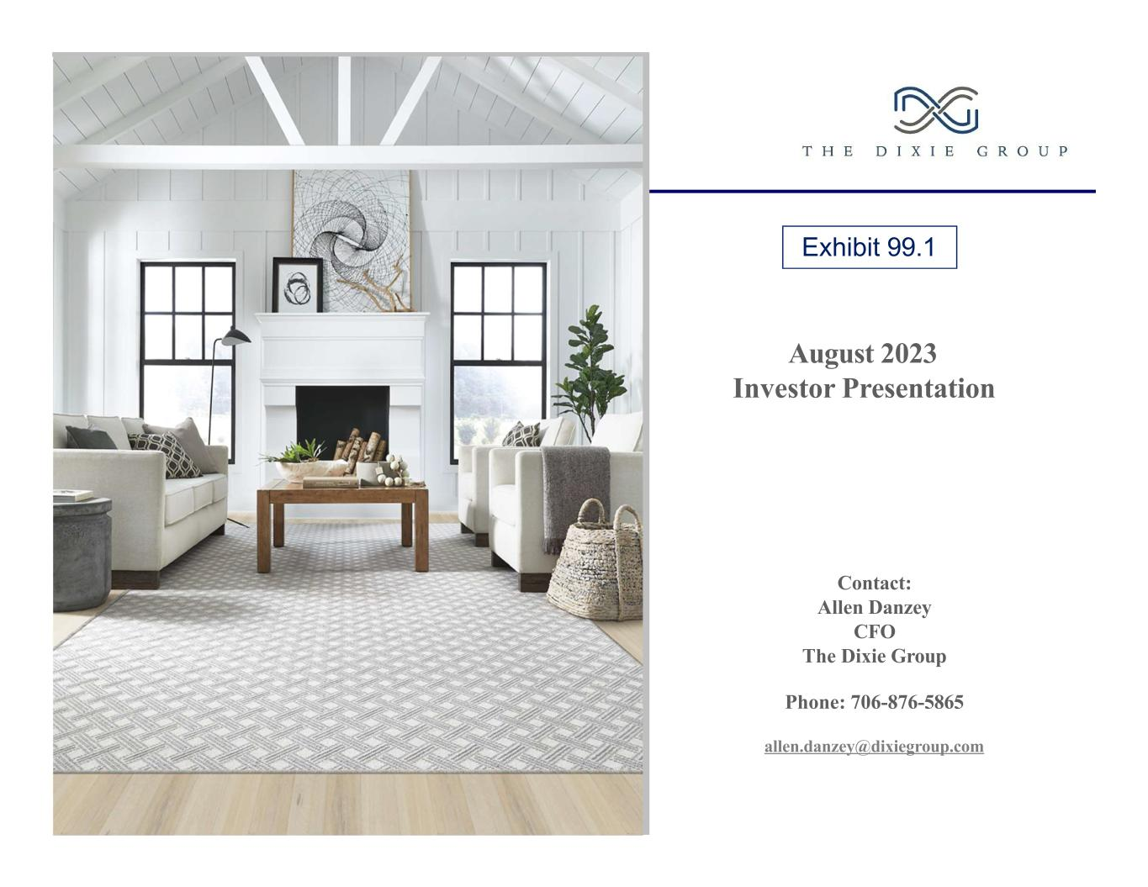
August 2023 Investor Presentation Contact: Allen Danzey CFO The Dixie Group Phone: 706-876-5865 allen.danzey@dixiegroup.com Exhibit 99.1

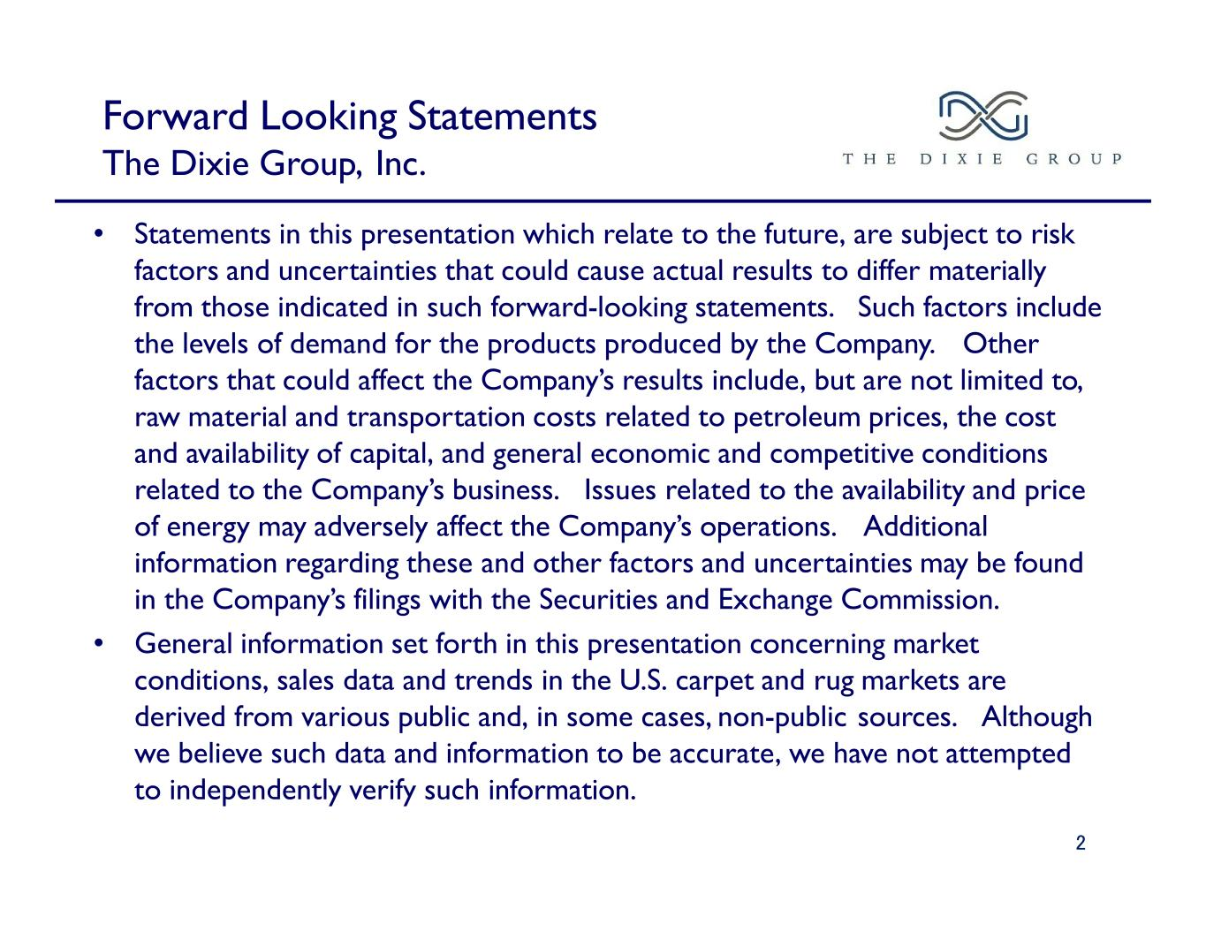
Forward Looking Statements The Dixie Group, Inc. • Statements in this presentation which relate to the future, are subject to risk factors and uncertainties that could cause actual results to differ materially from those indicated in such forward-looking statements. Such factors include the levels of demand for the products produced by the Company. Other factors that could affect the Company’s results include, but are not limited to, raw material and transportation costs related to petroleum prices, the cost and availability of capital, and general economic and competitive conditions related to the Company’s business. Issues related to the availability and price of energy may adversely affect the Company’s operations. Additional information regarding these and other factors and uncertainties may be found in the Company’s filings with the Securities and Exchange Commission. • General information set forth in this presentation concerning market conditions, sales data and trends in the U.S. carpet and rug markets are derived from various public and, in some cases, non-public sources. Although we believe such data and information to be accurate, we have not attempted to independently verify such information. 2

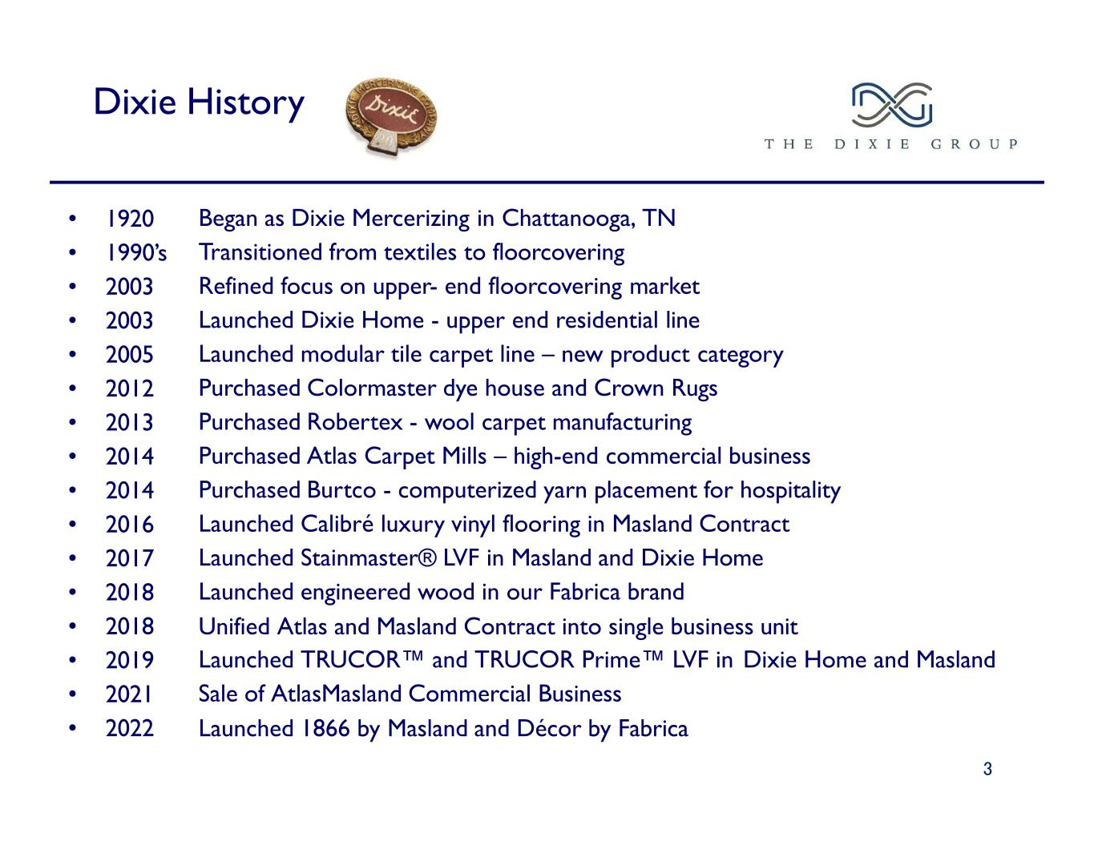
Dixie History • 1920 • 1990’s • 2003 • 2003 • 2005 • 2012 • 2013 • 2014 • 2014 • 2016 • 2017 • 2018 • 2018 • 2019 • 2021 • 2022 Began as Dixie Mercerizing in Chattanooga, TN Transitioned from textiles to floorcovering Refined focus on upper- end floorcovering market Launched Dixie Home - upper end residential line Launched modular tile carpet line – new product category Purchased Colormaster dye house and Crown Rugs Purchased Robertex - wool carpet manufacturing Purchased Atlas Carpet Mills – high-end commercial business Purchased Burtco - computerized yarn placement for hospitality Launched Calibré luxury vinyl flooring in Masland Contract Launched Stainmaster® LVF in Masland and Dixie Home Launched engineered wood in our Fabrica brand Unified Atlas and Masland Contract into single business unit Launched TRUCOR™ and TRUCOR Prime™ LVF in Dixie Home and Masland Sale of AtlasMasland Commercial Business Launched 1866 by Masland and Décor by Fabrica 3

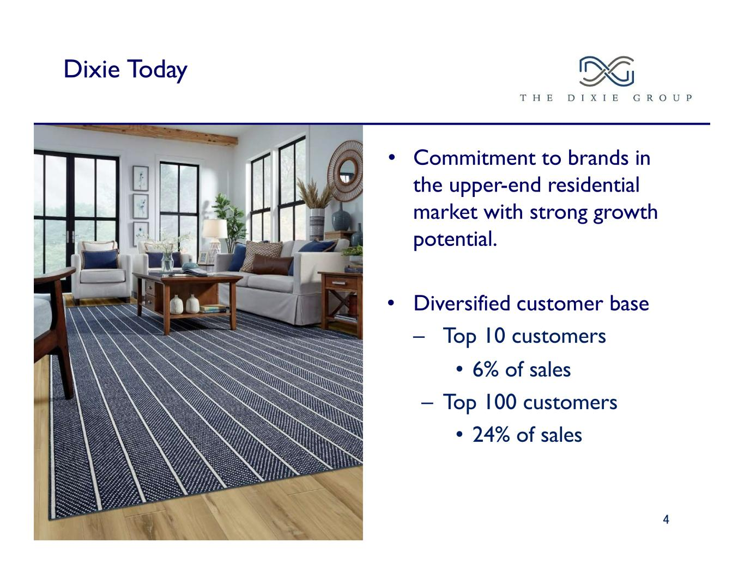
Dixie Today • Commitment to brands in the upper-end residential market with strong growth potential. • Diversified customer base – Top 10 customers • 6% of sales – Top 100 customers • 24% of sales 4

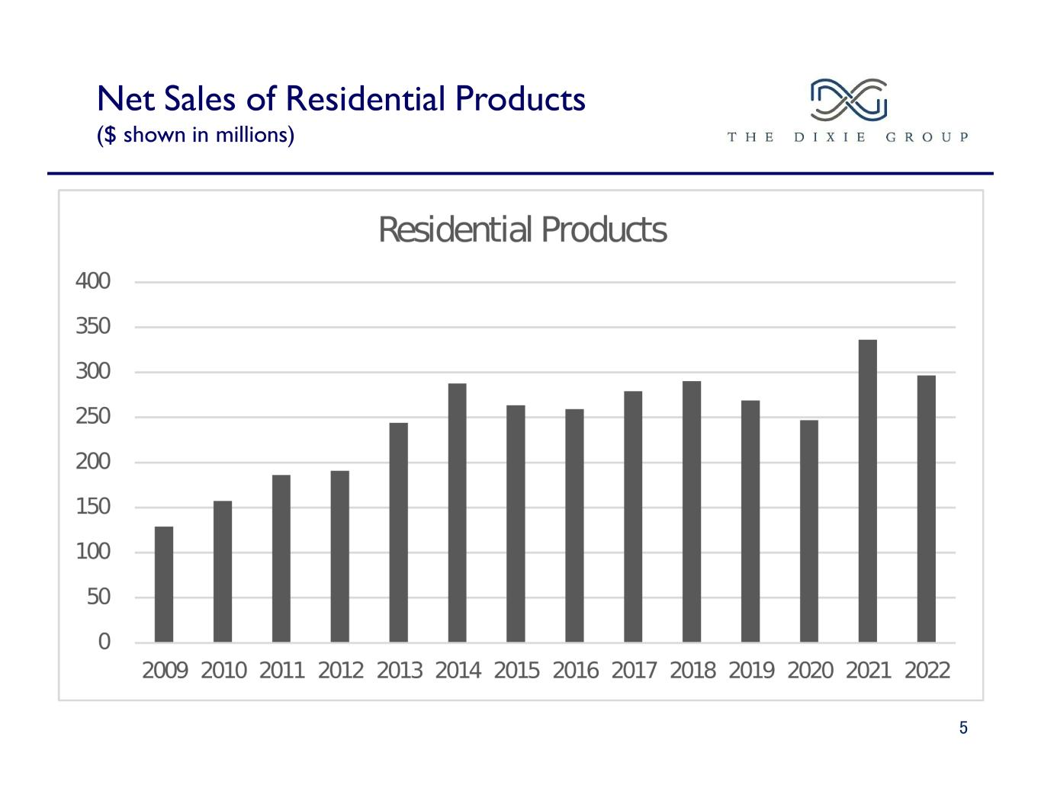
Net Sales of Residential Products ($ shown in millions) 5

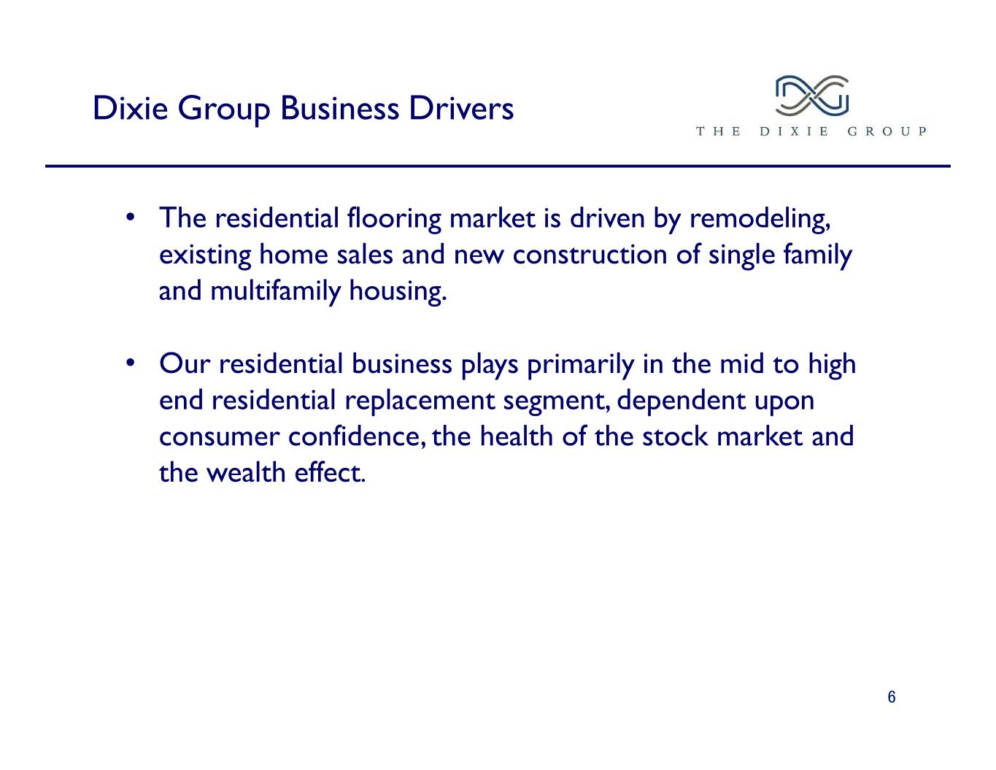
Dixie Group Business Drivers 6 • The residential flooring market is driven by remodeling, existing home sales and new construction of single family and multifamily housing. • Our residential business plays primarily in the mid to high end residential replacement segment, dependent upon consumer confidence, the health of the stock market and the wealth effect.

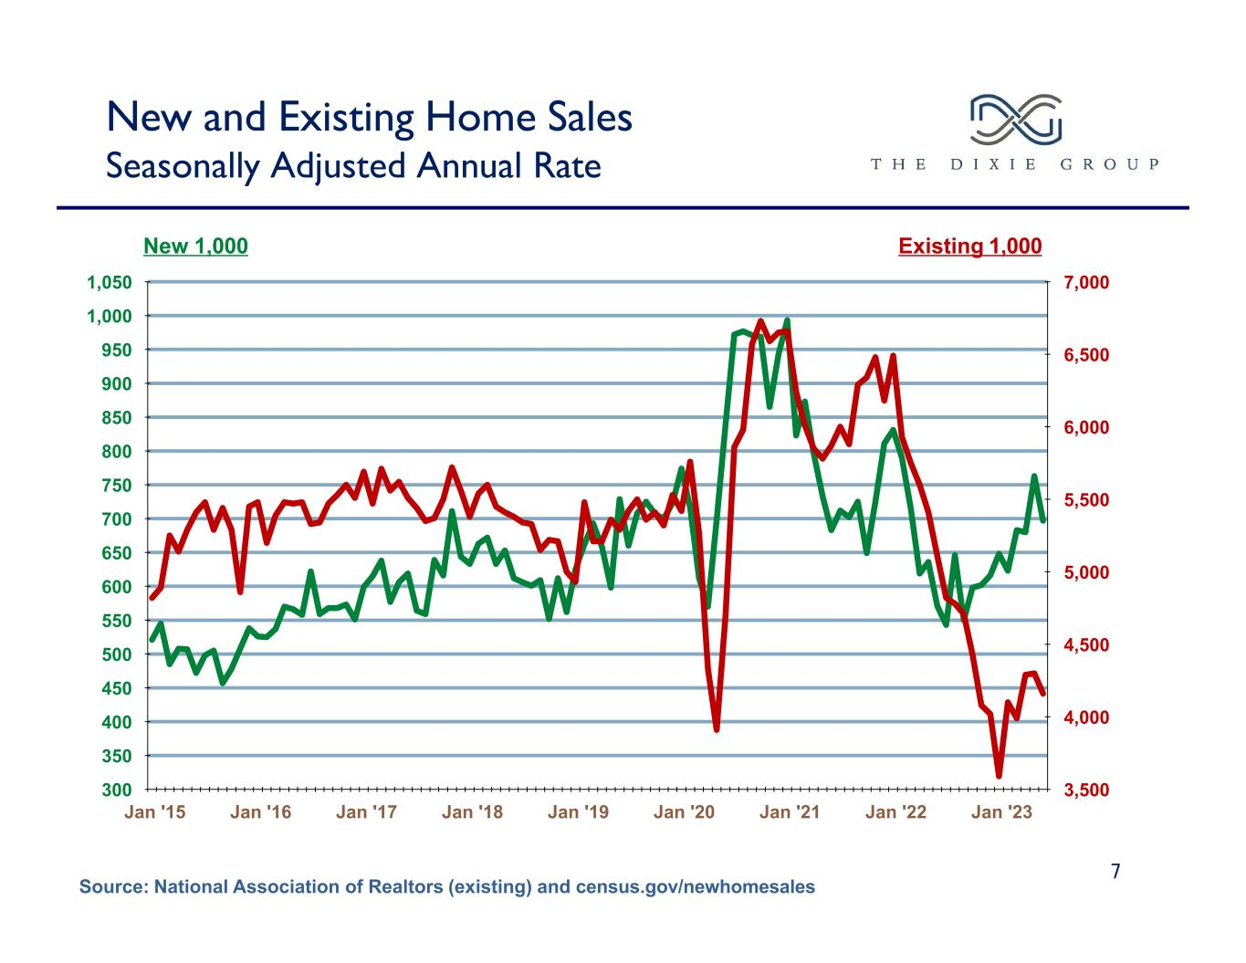
New and Existing Home Sales Seasonally Adjusted Annual Rate 7 New 1,000 Existing 1,000 Source: National Association of Realtors (existing) and census.gov/newhomesales Jan '15 Jan '16 Jan '17 Jan '18 Jan '19 Jan '20 Jan '21 Jan '22 Jan '23 300 350 400 450 500 550 600 650 700 750 800 850 900 950 1,000 1,050 3,500 4,000 4,500 5,000 5,500 6,000 6,500 7,000

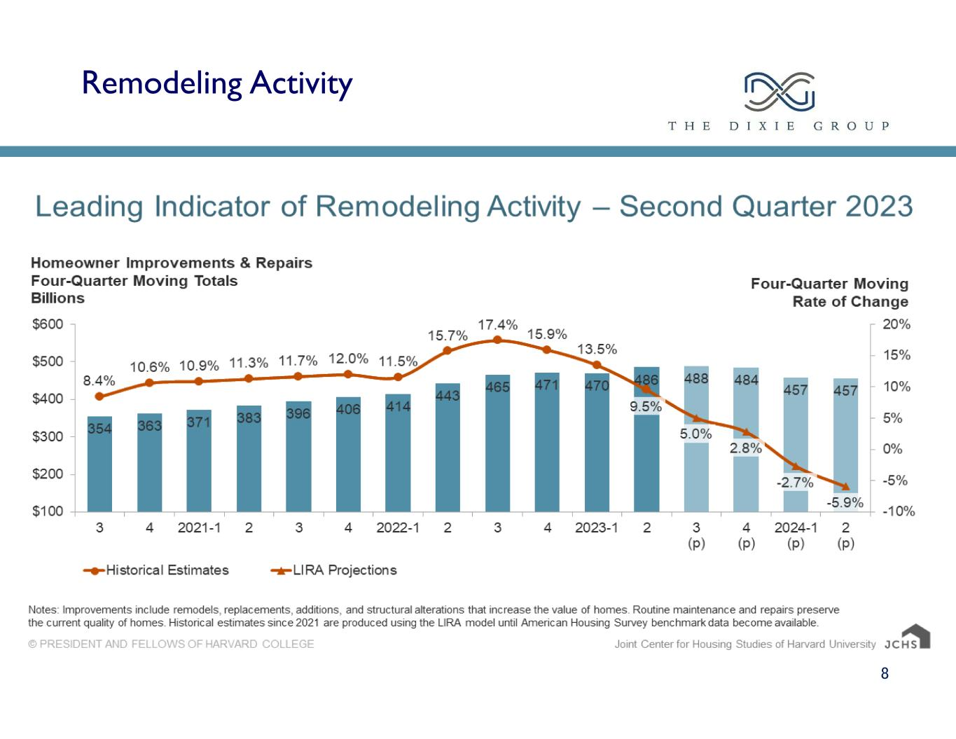
Remodeling Activity 8

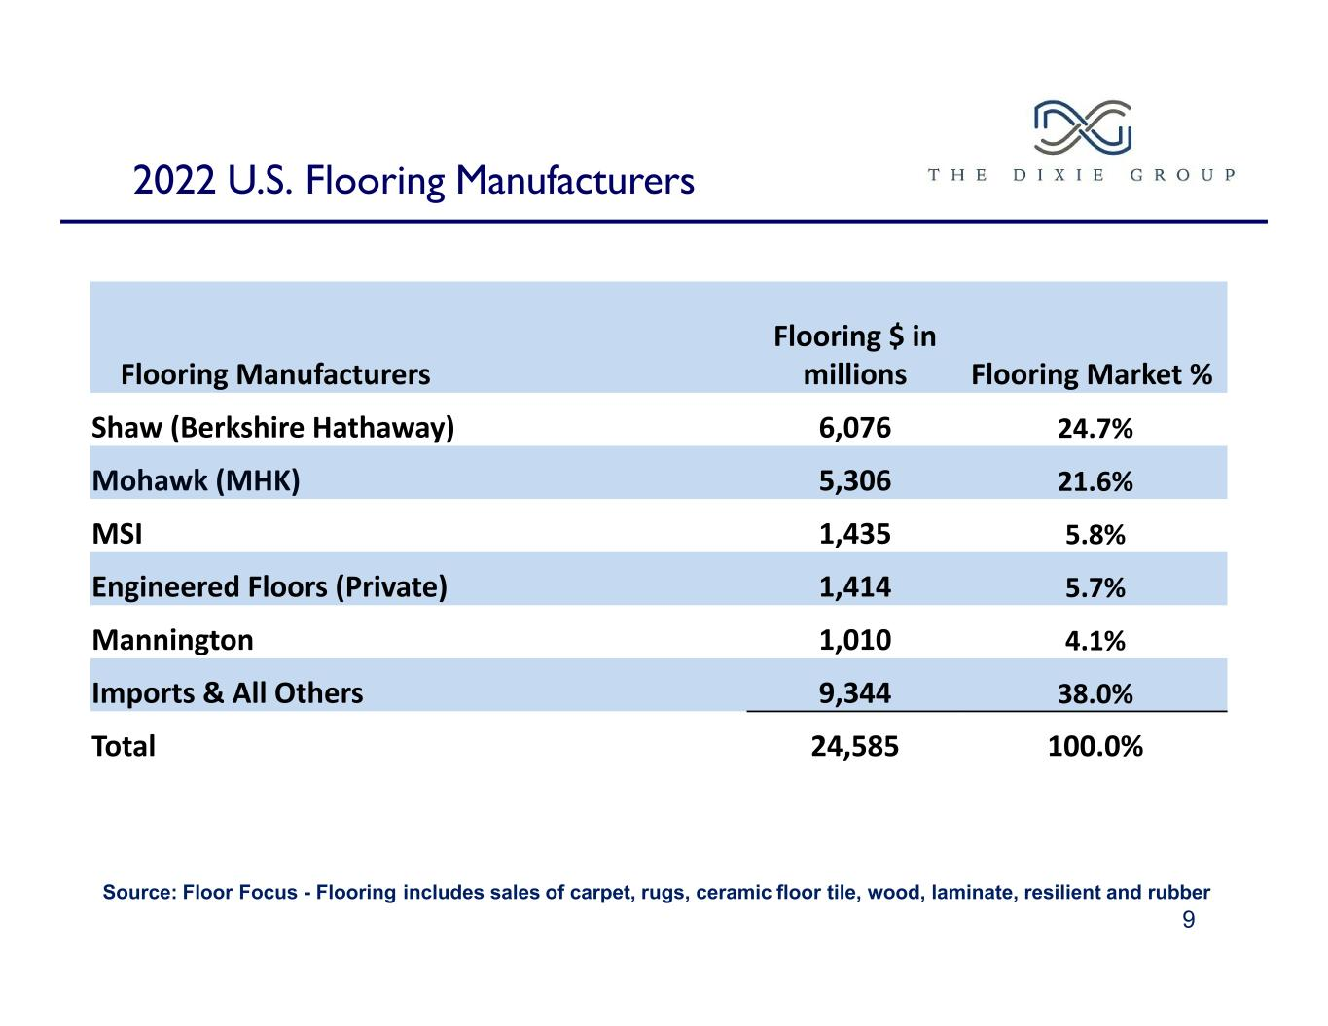
2022 U.S. Flooring Manufacturers Source: Floor Focus - Flooring includes sales of carpet, rugs, ceramic floor tile, wood, laminate, resilient and rubber 9 Flooring Manufacturers Flooring $ in millions Flooring Market % Shaw (Berkshire Hathaway) 6,076 24.7% Mohawk (MHK) 5,306 21.6% MSI 1,435 5.8% Engineered Floors (Private) 1,414 5.7% Mannington 1,010 4.1% Imports & All Others 9,344 38.0% Total 24,585 100.0%

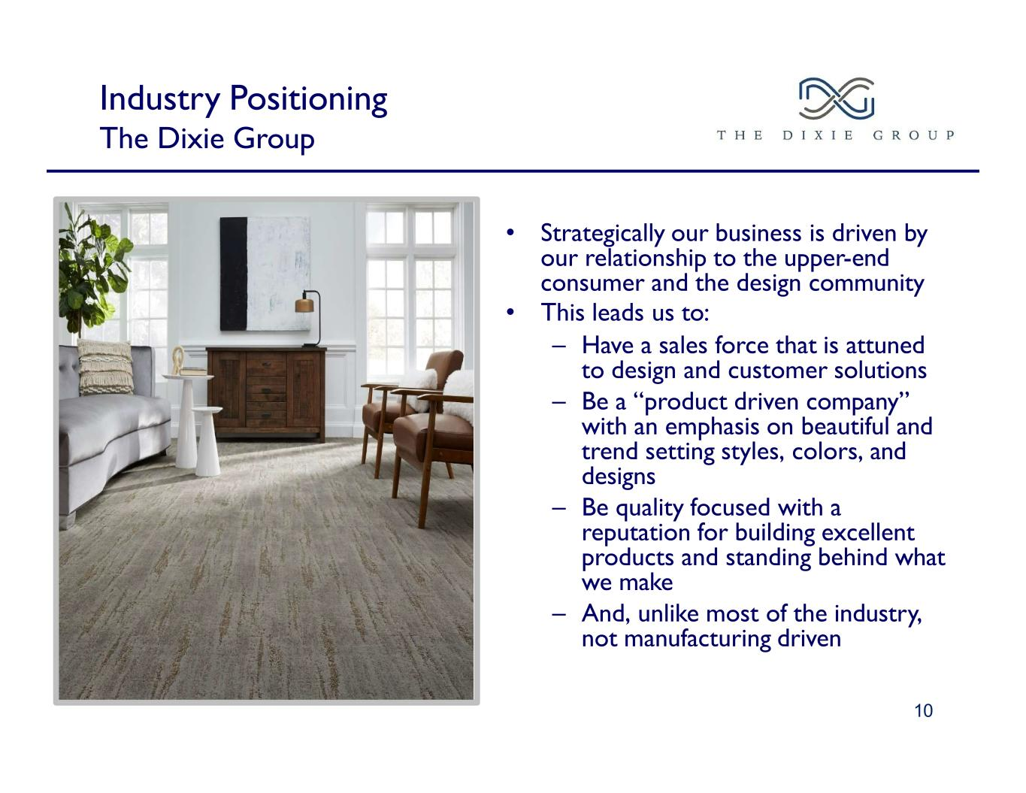
Industry Positioning The Dixie Group • Strategically our business is driven by our relationship to the upper-end consumer and the design community • This leads us to: – Have a sales force that is attuned to design and customer solutions – Be a “product driven company” with an emphasis on beautiful and trend setting styles, colors, and designs – Be quality focused with a reputation for building excellent products and standing behind what we make – And, unlike most of the industry, not manufacturing driven 10

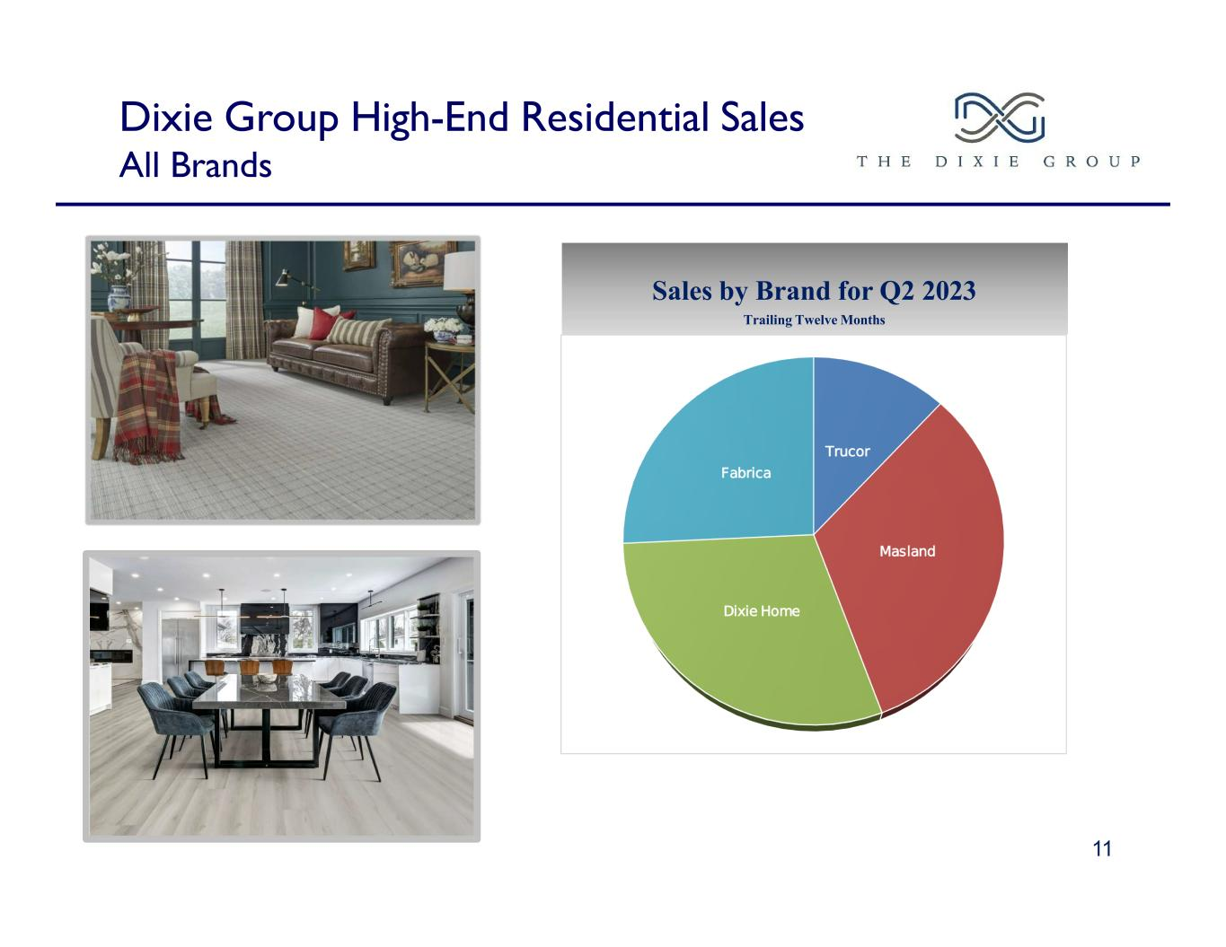
Dixie Group High-End Residential Sales All Brands 11 Sales by Brand for Q2 2023 Trailing Twelve Months

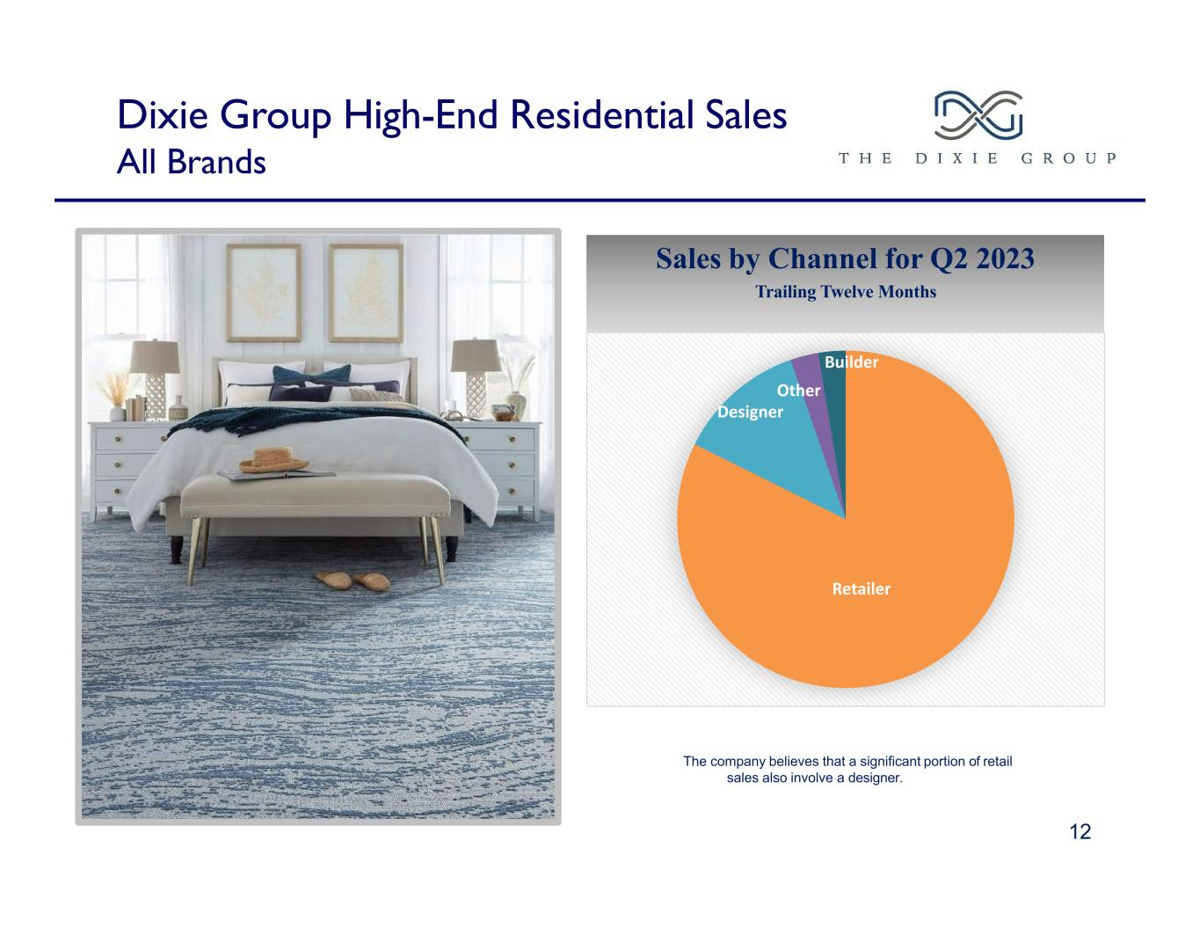
Dixie Group High-End Residential Sales All Brands Sales by Channel for Q2 2023 Trailing Twelve Months The company believes that a significant portion of retail sales also involve a designer. 12 Retailer Designer Other Builder

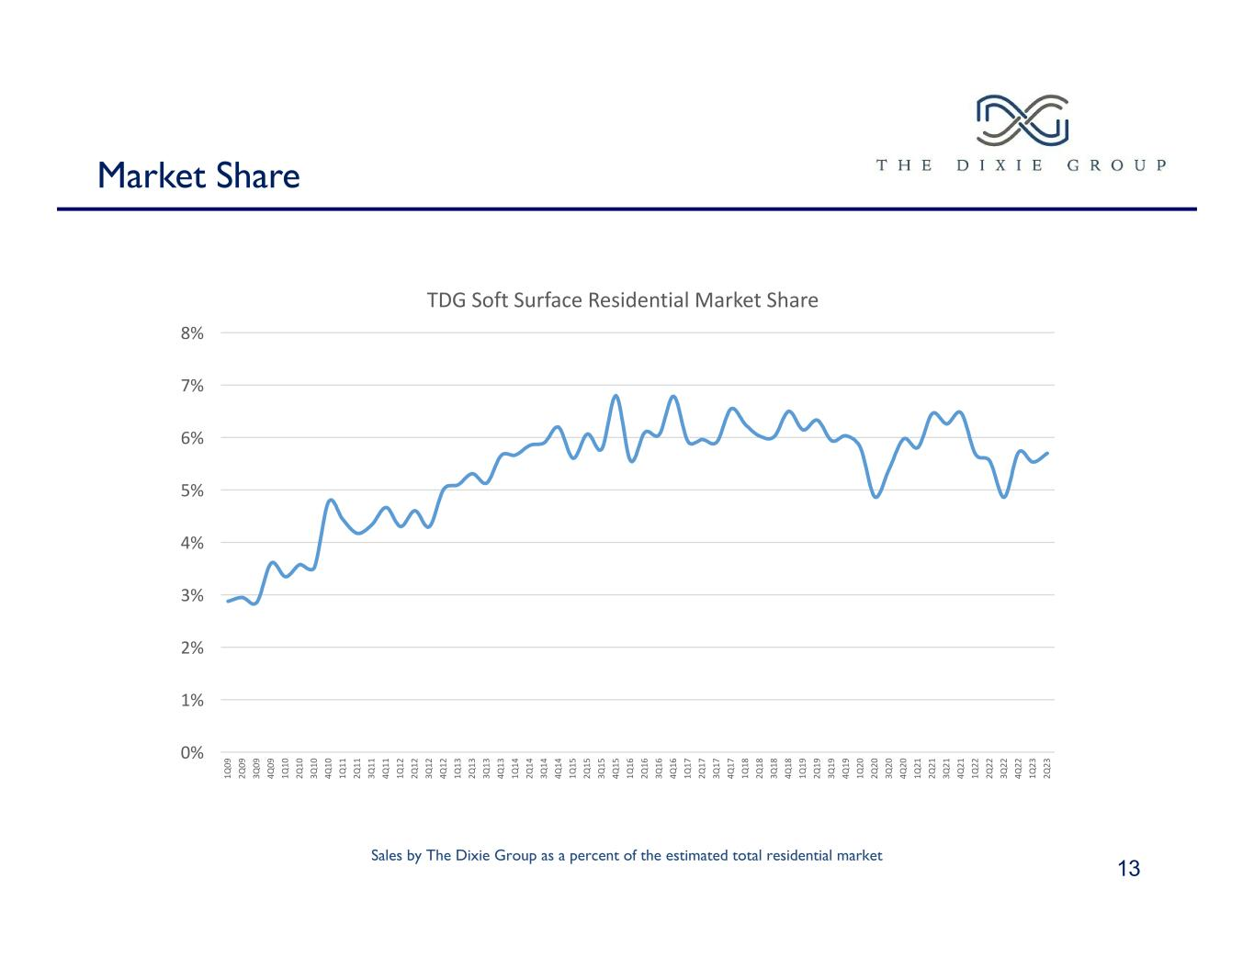
Market Share 13 Sales by The Dixie Group as a percent of the estimated total residential market 1Q 09 2Q 09 3Q 09 4Q 09 1Q 10 2Q 10 3Q 10 4Q 10 1Q 11 2Q 11 3Q 11 4Q 11 1Q 12 2Q 12 3Q 12 4Q 12 1Q 13 2Q 13 3Q 13 4Q 13 1Q 14 2Q 14 3Q 14 4Q 14 1Q 15 2Q 15 3Q 15 4Q 15 1Q 16 2Q 16 3Q 16 4Q 16 1Q 17 2Q 17 3Q 17 4Q 17 1Q 18 2Q 18 3Q 18 4Q 18 1Q 19 2Q 19 3Q 19 4Q 19 1Q 20 2Q 20 3Q 20 4Q 20 1Q 21 2Q 21 3Q 21 4Q 21 1Q 22 2Q 22 3Q 22 4Q 22 1Q 23 2Q 23 0% 1% 2% 3% 4% 5% 6% 7% 8% TDG Soft Surface Residential Market Share

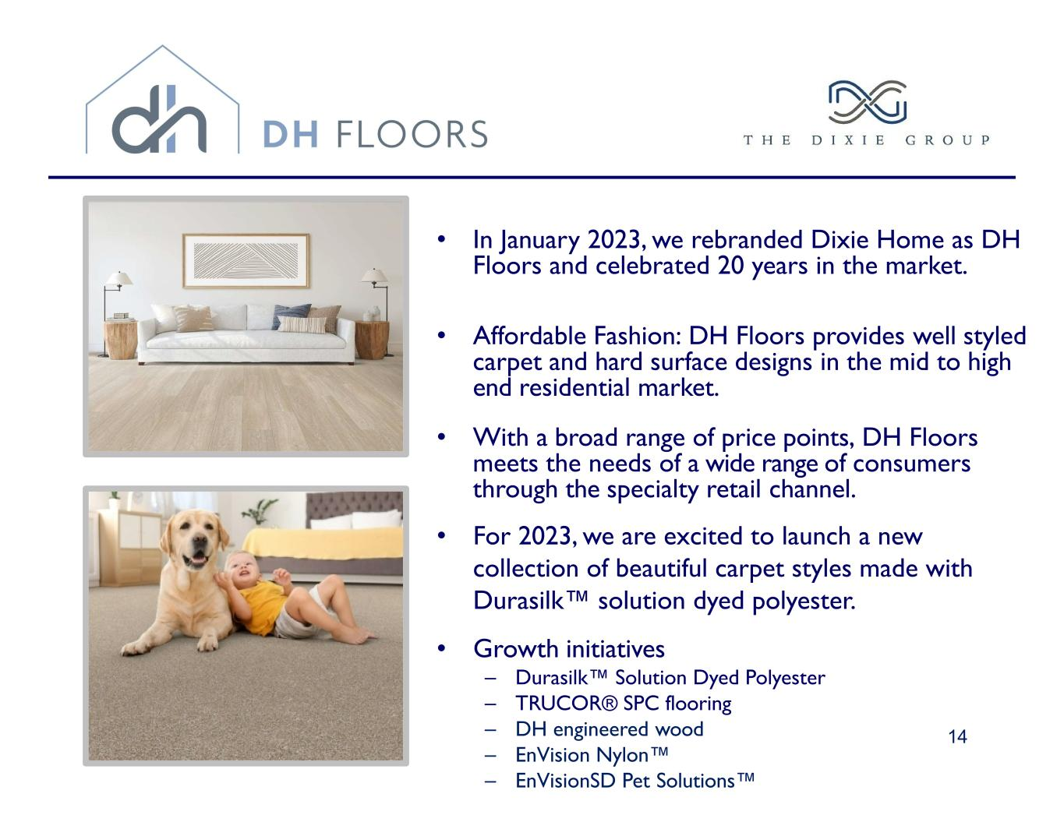
• In January 2023, we rebranded Dixie Home as DH Floors and celebrated 20 years in the market. • Affordable Fashion: DH Floors provides well styled carpet and hard surface designs in the mid to high end residential market. • With a broad range of price points, DH Floors meets the needs of a wide range of consumers through the specialty retail channel. • For 2023, we are excited to launch a new collection of beautiful carpet styles made with Durasilk™ solution dyed polyester. • Growth initiatives – Durasilk™ Solution Dyed Polyester – TRUCOR® SPC flooring – DH engineered wood – EnVision Nylon™ – EnVisionSD Pet Solutions™ 14

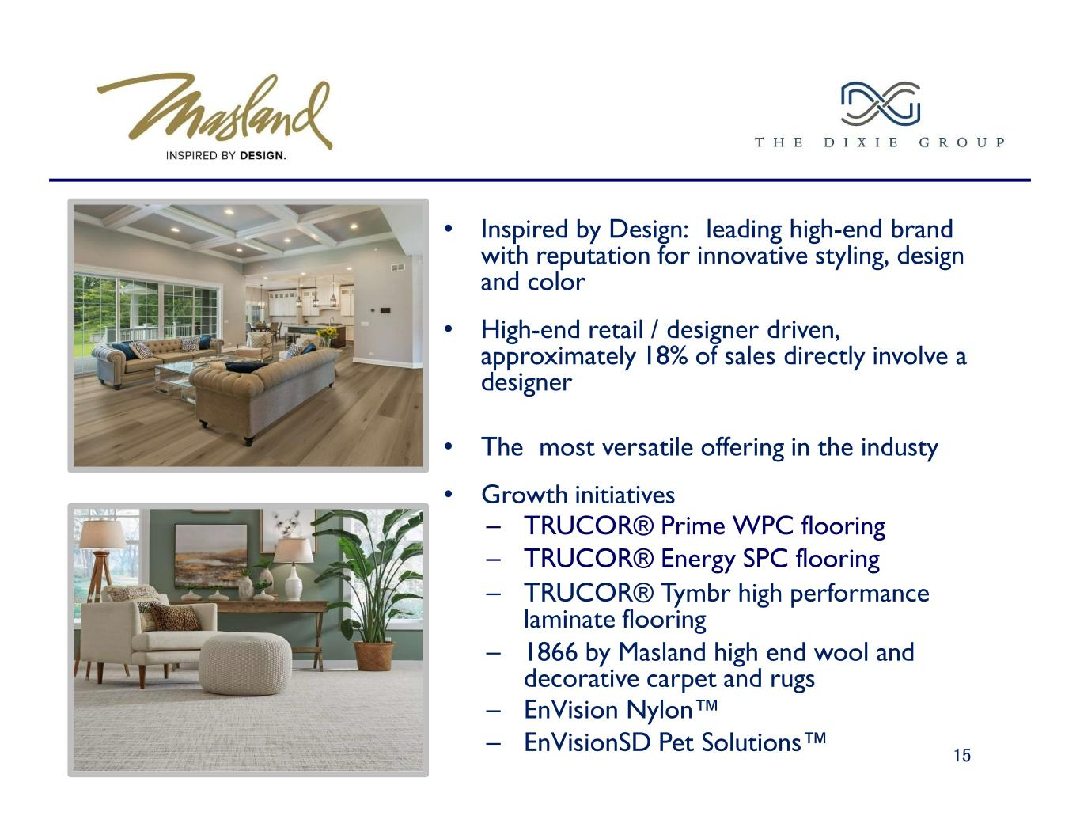
• Inspired by Design: leading high-end brand with reputation for innovative styling, design and color • High-end retail / designer driven, approximately 18% of sales directly involve a designer • The most versatile offering in the industy • Growth initiatives – TRUCOR® Prime WPC flooring – TRUCOR® Energy SPC flooring – TRUCOR® Tymbr high performance laminate flooring – 1866 by Masland high end wool and decorative carpet and rugs – EnVision Nylon™ – EnVisionSD Pet Solutions™ 15

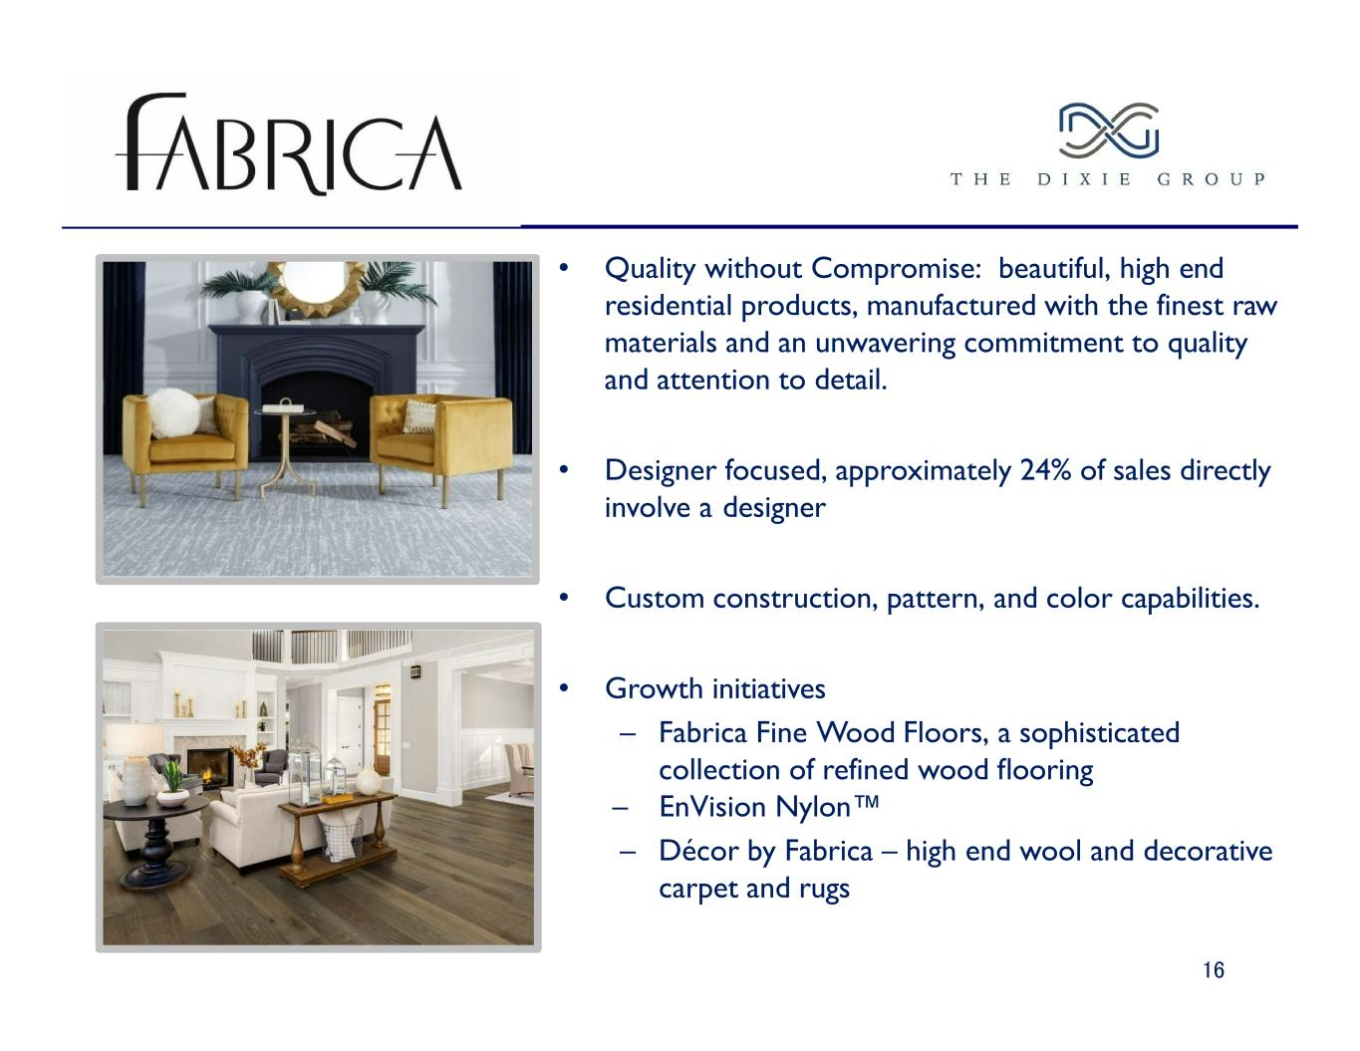
• Quality without Compromise: beautiful, high end residential products, manufactured with the finest raw materials and an unwavering commitment to quality and attention to detail. • Designer focused, approximately 24% of sales directly involve a designer • Custom construction, pattern, and color capabilities. • Growth initiatives – Fabrica Fine Wood Floors, a sophisticated collection of refined wood flooring – EnVision Nylon™ – Décor by Fabrica – high end wool and decorative carpet and rugs 16

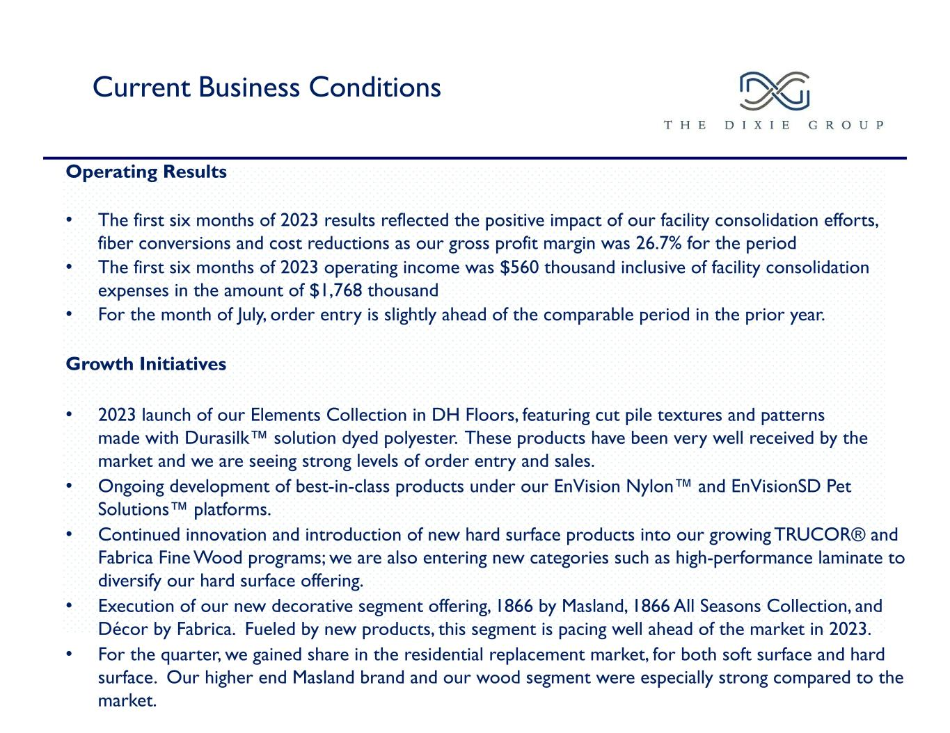
Current Business Conditions Operating Results • The first six months of 2023 results reflected the positive impact of our facility consolidation efforts, fiber conversions and cost reductions as our gross profit margin was 26.7% for the period • The first six months of 2023 operating income was $560 thousand inclusive of facility consolidation expenses in the amount of $1,768 thousand • For the month of July, order entry is slightly ahead of the comparable period in the prior year. Growth Initiatives • 2023 launch of our Elements Collection in DH Floors, featuring cut pile textures and patterns made with Durasilk™ solution dyed polyester. These products have been very well received by the market and we are seeing strong levels of order entry and sales. • Ongoing development of best-in-class products under our EnVision Nylon™ and EnVisionSD Pet Solutions™ platforms. • Continued innovation and introduction of new hard surface products into our growing TRUCOR® and Fabrica Fine Wood programs; we are also entering new categories such as high-performance laminate to diversify our hard surface offering. • Execution of our new decorative segment offering, 1866 by Masland, 1866 All Seasons Collection, and Décor by Fabrica. Fueled by new products, this segment is pacing well ahead of the market in 2023. • For the quarter, we gained share in the residential replacement market, for both soft surface and hard surface. Our higher end Masland brand and our wood segment were especially strong compared to the market.

